Assignment 5B
Created By – Anurag Laldher

Part B
- Create a text editor utility, using which you can
  - Add a line at top
  - Add a line at bottom
  - Add a line at specific line number
  - Replace word
  - Delete word
  - Insert word
  - Delete a line
  - Delete a line containeing a word
  - ./otTextEditor addLineTop <file> <line>
  - ./otTextEditor addLineBottom <file> <line>
  - ./otTextEditor addLineAt <file> <linenumber> <line>
  - ./otTextEditor updateFirstWord <file> <word> <word2>
  - ./otTextEditor updateAllWords <file> <word> <word2>
  - ./otTextEditor insertWord <file> <word1> <word2> <word to be inserted>
  - ./otTextEditor deleteLine <file> <line no>
  - ./otTextEditor deleteLine <file> <line no> <word>
  - Also come with your own features of text editor

Script
Nano otTextEditor.sh
#!/usr/bin/env bash

usage() {
cat <<EOF
Usage:

Add line at top
./otTextEditor addlinetop <file> <line>

Add line at bottom
./otTextEditor addlinebottom <file> <line>

Add line at specific position
./otTextEditor addlineat <file> <line number> <line>

Replace first occurrence of a word
./otTextEditor updatefirstword <file> <old word> <new word>

Replace all occurrences of a word
./otTextEditor updateallwords <file> <old word> <new word>

Delete first occurrence of a word
./otTextEditor deleteword <file> <word>

Insert a word after another word
./otTextEditor insertword <file> <existing word> <new word>

Delete a line
./otTextEditor deleteline <file> <line number>

Delete lines containing a word
./otTextEditor deletelinecontaining <file> <word>

Show file
./otTextEditor show <file>

Count lines
./otTextEditor countlines <file>

Count words
./otTextEditor countwords <file>

Show line numbers
./otTextEditor linenumbers <file>
EOF
exit 1
}

# Check file exists
check_file() {
[ -f "$1" ] || {
echo "Error: File '$1' not found."
exit 1
}
}

#######################################
# Add Line at Top
#######################################
addlinetop() {
check_file "$1"
sed -i "1i $2" "$1"
}

#######################################
# Add Line at Bottom
#######################################
addlinebottom() {
check_file "$1"
echo "$2" >> "$1"
}

#######################################
# Add Line at Specific Position
#######################################
addlineat() {
check_file "$1"
sed -i "${2}i $3" "$1"
}

#######################################
# Replace First Occurrence
#######################################
updatefirstword() {
check_file "$1"
sed -i "0,/$2/s//$3/" "$1"
}

#######################################
# Replace All Occurrences
#######################################
updateallwords() {
check_file "$1"
sed -i "s/$2/$3/g" "$1"
}

#######################################
# Delete First Occurrence of Word
#######################################
deleteword() {
check_file "$1"
sed -i "0,/$2/s//$3/" "$1"
}

#######################################
# Insert Word
#######################################
insertword() {
check_file "$1"
sed -i "s/$2/$2 $3/g" "$1"
}

#######################################
# Delete Line
#######################################
deleteline() {
check_file "$1"
sed -i "${2}d" "$1"
}

#######################################
# Delete Line Containing Word
#######################################
deletelinecontaining() {
check_file "$1"
sed -i "/$2/d" "$1"
}

#######################################
# Extra Feature : Show File
#######################################
show() {
check_file "$1"
cat "$1"
}

#######################################
# Extra Feature : Count Lines
#######################################
countlines() {
check_file "$1"
wc -l "$1"
}

#######################################
# Extra Feature : Count Words
#######################################
countwords() {
check_file "$1"
wc -w "$1"
}

#######################################
# Extra Feature : Show Line Numbers
#######################################
linenumbers() {
check_file "$1"
nl "$1"
}

#######################################
# Main
#######################################

case "$1" in

addlinetop)
[ $# -eq 3 ] || usage
addlinetop "$2" "$3"
;;
addlinebottom)
[ $# -eq 3 ] || usage
addlinebottom "$2" "$3"
;;
addlineat)
[ $# -eq 4 ] || usage
addlineat "$2" "$3" "$4"
;;
updatefirstword)
[ $# -eq 4 ] || usage
updatefirstword "$2" "$3" "$4"
;;
updateallwords)
[ $# -eq 4 ] || usage
updateallwords "$2" "$3" "$4"
;;
deleteword)
[ $# -eq 3 ] || usage
deleteword "$2" "$3" ""
;;
insertword)
[ $# -eq 4 ] || usage
insertword "$2" "$3" "$4"
;;
deleteline)
[ $# -eq 3 ] || usage
deleteline "$2" "$3"
;;
deletelinecontaining)
[ $# -eq 3 ] || usage
deletelinecontaining "$2" "$3"
;;
show)
[ $# -eq 2 ] || usage
show "$2"
;;
countlines)
[ $# -eq 2 ] || usage
countlines "$2"
;;
countwords)
[ $# -eq 2 ] || usage
countwords "$2"
;;
linenumbers)
[ $# -eq 2 ] || usage
linenumbers "$2"
;;
*)
usage
;;
esac

Explanation

Shebang
#!/usr/bin/env bash

Statement | Explanation
#! | Called the Shebang. It tells the operating system which interpreter should execute the script.
/usr/bin/env | Searches the user's environment to locate the bash executable.
Bash | Executes the script using the Bash shell.

usage()
usage() {
cat <<EOF
Usage:

Add line at top
./otTextEditor addLineTop <file> <line>

Add line at bottom
./otTextEditor addLineBottom <file> <line>

Add line at specific position
./otTextEditor addLineAt <file> <line number> <line>

Replace first occurrence of a word
./otTextEditor updateFirstWord <file> <old word> <new word>

Replace all occurrences
./otTextEditor updateAllWords <file> <old word> <new word>

Delete first occurrence of a word
./otTextEditor deleteWord <file> <word>

Insert a word
./otTextEditor insertWord <file> <existing word> <new word>

Delete a line
./otTextEditor deleteLine <file> <line number>

Delete line containing a word
./otTextEditor deleteLineContaining <file> <word>

Show file
./otTextEditor show <file>

Count lines
./otTextEditor countLines <file>

Count words
./otTextEditor countWords <file>

Show line numbers
./otTextEditor lineNumbers <file>
EOF

exit 1
}

Statement | Explanation
usage() { | Defines a function named usage that displays the help menu.
cat <<EOF | Starts a Here Document (Heredoc). Everything between <<EOF and EOF is displayed exactly as written.
Usage: | Displays the title of the help menu.
./otTextEditor addLineTop ... | Displays the syntax for adding a line at the beginning of a file.
./otTextEditor addLineBottom ... | Displays the syntax for appending a line to the end of a file.
./otTextEditor addLineAt ... | Displays the syntax for inserting a line at a specified line number.
./otTextEditor updateFirstWord ... | Displays the syntax for replacing only the first occurrence of a word.
./otTextEditor updateAllWords ... | Displays the syntax for replacing every occurrence of a word.
./otTextEditor deleteWord ... | Displays the syntax for deleting the first occurrence of a word.
./otTextEditor insertWord ... | Displays the syntax for inserting a new word after an existing word.
./otTextEditor deleteLine ... | Displays the syntax for deleting a specific line.
./otTextEditor deleteLineContaining ... | Displays the syntax for deleting all lines containing a specified word.
./otTextEditor show ... | Displays the syntax for printing the file contents.
./otTextEditor countLines ... | Displays the syntax for counting the number of lines.
./otTextEditor countWords ... | Displays the syntax for counting the number of words.
./otTextEditor lineNumbers ... | Displays the syntax for printing the file with line numbers.
EOF | Marks the end of the Here Document.
exit 1 | Terminates the script with exit status 1, indicating incorrect usage or invalid arguments.
} | Ends the usage() function.

check_file() [ ./otTextEditor addLineTop sample.txt "Welcome"]
check_file() {
[ -f "$1" ] || {
echo "Error: File '$1' not found."
exit 1
}
}

Statement | Explanation
check_file() { | Defines a function named check_file that verifies whether the specified file exists.
[ -f "$1" ] | Checks whether the file passed as the first argument exists and is a regular file.
`
{ ... } | Groups multiple commands together so they can be executed as a single block.
echo "Error: File '$1' not found." | Displays an error message if the file does not exist.
exit 1 | Stops the script with an error status.
} | Ends the command block.
} | Ends the check_file() function.

addLineTop()
addLineTop() {
check_file "$1"
sed -i "1i $2" "$1"
}

Statement | Explanation
addLineTop() { | Defines a function named addLineTop.
check_file "$1" | Calls the check_file() function to ensure the specified file exists.
sed -i "1i $2" "$1" | Inserts the text stored in $2 before line 1 of the file.
sed | Stream Editor used to edit text files.
-i | Performs the modification directly in the original file (in-place editing).
"1i $2" | 1 represents line number 1, and i means insert before that line.
"$1" | The file to be modified.
} | Ends the addLineTop() function.

addLineBottom()
addLineBottom() {
check_file "$1"
echo "$2" >> "$1"
}

Statement | Explanation
addLineBottom() { | Defines the addLineBottom function.
check_file "$1" | Ensures the file exists before modifying it.
echo "$2" | Prints the new line provided by the user.
>> | Appends the output to the end of the file without removing existing contents.
"$1" | File that will be modified.
} | Ends the function.

addLineAt()
addLineAt() {
check_file "$1"
sed -i "${2}i $3" "$1"
}

Statement | Explanation
addLineAt() { | Defines the addLineAt function.
check_file "$1" | Verifies the file exists.
sed -i "${2}i $3" "$1" | Inserts the text before the specified line number.
${2} | The line number provided by the user.
i | Insert before the specified line.
$3 | The new line to insert.
"$1" | File to modify.
} | Ends the function.

updateFirstWord()
updateFirstWord() {
check_file "$1"
sed -i "0,/$2/s//$3/" "$1"
}

Statement | Explanation
updateFirstWord() { | Defines a function named updateFirstWord.
check_file "$1" | Verifies that the specified file exists before modifying it.
sed -i "0,/$2/s//$3/" "$1" | Replaces only the first occurrence of the specified word with a new word.
sed | Stream Editor used to search and modify text.
-i | Performs the modification directly in the original file.
0,/$2/ | Searches from the beginning of the file until the first match of the word.
s// | Performs the substitution on the matched word.
$3 | The replacement word.
"$1" | File to modify.
} | Ends the function.

updateAllWords()
updateAllWords() {
check_file "$1"
sed -i "s/$2/$3/g" "$1"
}

Statement | Explanation
updateAllWords() { | Defines the updateAllWords function.
check_file "$1" | Verifies the file exists.
sed -i "s/$2/$3/g" "$1" | Replaces all occurrences of the old word with the new word.
s | Substitute command.
$2 | Word to search for.
$3 | Replacement word.
g | Global flag that replaces every occurrence on each line.
"$1" | File to modify.
} | Ends the function.

deleteWord()
deleteWord() {
check_file "$1"
sed -i "0,/$2/s//$3/" "$1"
}

Statement | Explanation
deleteWord() { | Defines the deleteWord function.
check_file "$1" | Verifies that the file exists.
sed -i "0,/$2/s//$3/" "$1" | Replaces the first occurrence of the specified word with an empty string.
$2 | Word to remove.
$3 | Empty string ("") passed from the case statement.
} | Ends the function.

insertWord()
insertWord() {
check_file "$1"
sed -i "s/$2/$2 $3/g" "$1"
}

Statement | Explanation
insertWord() { | Defines the insertWord function.
check_file "$1" | Ensures the file exists.
sed -i "s/$2/$2 $3/g" "$1" | Replaces every occurrence of the existing word with the existing word followed by the new word.
$2 | Existing word.
$3 | New word to insert.
g | Applies the replacement globally.
} | Ends the function.

deleteLine()
deleteLine() {
check_file "$1"
sed -i "${2}d" "$1"
}

Statement | Explanation
deleteLine() { | Defines a function named deleteLine.
check_file "$1" | Verifies that the specified file exists before modifying it.
sed -i "${2}d" "$1" | Deletes the specified line from the file.
sed | Stream Editor used to edit text files.
-i | Performs the modification directly in the original file.
${2} | Represents the line number passed by the user.
D | sed delete command. Deletes the specified line.
"$1" | File to modify.
} | Ends the function.

deleteLineContaining()
deleteLineContaining() {
check_file "$1"
sed -i "/$2/d" "$1"
}

Statement | Explanation
deleteLineContaining() { | Defines the deleteLineContaining function.
check_file "$1" | Ensures the file exists.
sed -i "/$2/d" "$1" | Deletes every line containing the specified word.
/pattern/ | Searches for the specified pattern.
d | Deletes every matching line.
"$1" | File to modify.
} | Ends the function.

show()
show() {
check_file "$1"
cat "$1"
}

Statement | Explanation
show() { | Defines the show function.
check_file "$1" | Verifies the file exists.
cat "$1" | Displays the contents of the file.
cat | Concatenates and prints file contents to the terminal.
} | Ends the function.

countLines()
countLines() {
check_file "$1"
wc -l "$1"
}

Statement | Explanation
countLines() { | Defines the countLines function.
check_file "$1" | Ensures the file exists.
wc -l "$1" | Counts the total number of lines.
wc | Word Count command.
-l | Counts only lines.
} | Ends the function.

countWords()
countWords() {
check_file "$1"
wc -w "$1"
}

Statement | Explanation
countWords() { | Defines the countWords function.
check_file "$1" | Ensures the file exists.
wc -w "$1" | Counts the total number of words.
-w | Counts words only.
} | Ends the function.

lineNumbers()
lineNumbers() {
check_file "$1"
nl "$1"
}

Statement | Explanation
lineNumbers() { | Defines the lineNumbers function.
check_file "$1" | Verifies the file exists.
nl "$1" | Displays every line with its corresponding line number.
nl | Number Lines command.
} | Ends the function.

Validation Commands
- Create a sample file:
  - cat > sample.txt <<EOF
  - The Alchemist — Author: Paulo Coelho
  - Harry Potter and the Philosopher's Stone — Author: J. K. Rowling
  - The Hobbit — Author: J. R. R. Tolkien
  - Pride and Prejudice — Author: Jane Austen
  - Wings of Fire — Authors: A. P. J. Abdul Kalam and Arun Tiwari
  - EOF

- Add line at top
./otTextEditor addlinetop book_editors "Famous Books and Editors"

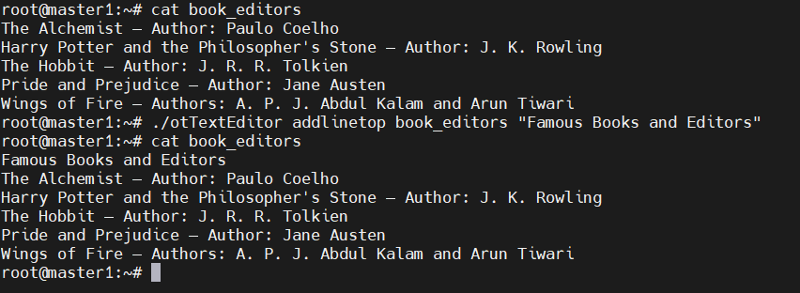

- Add line at bottom
./otTextEditor addlineat book_editors 2 " You have inserted me at 2nd line of book editors"
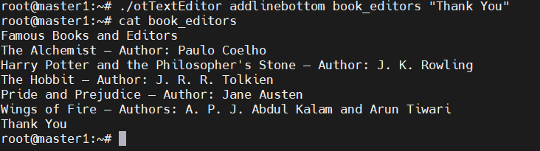

- Add line at line 2
./otTextEditor addlineat book_editors 2 "You have inserted me at 2nd line of book editors”

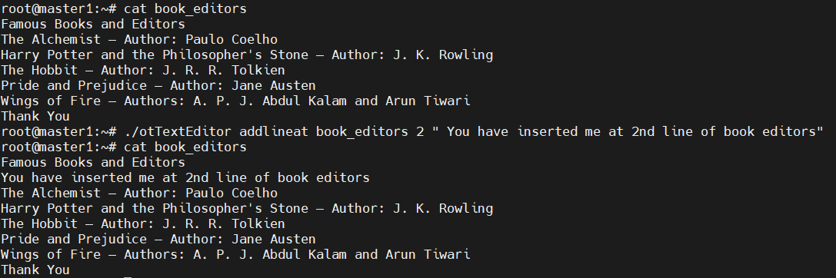

- Replace first occurrence
  - ./otTextEditor updatefirstword book_editors Famous Popular

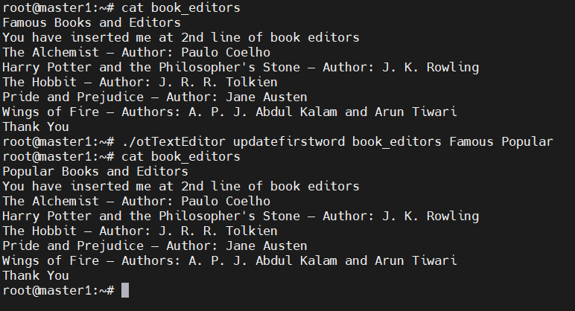

- Replace all occurrences
  - ./otTextEditor updateallwords book_editors Author Writer

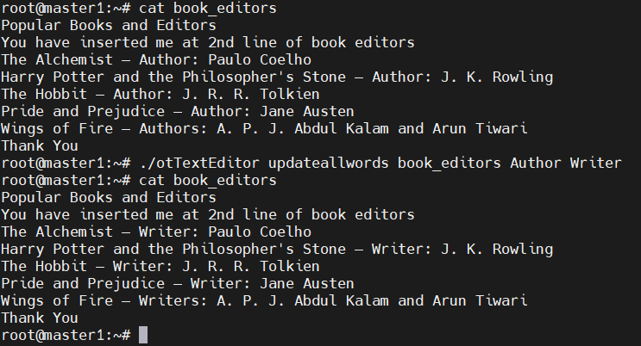

- Delete first occurrence of a word
  - ./otTextEditor deleteword book_editors "Arun Tiwari"

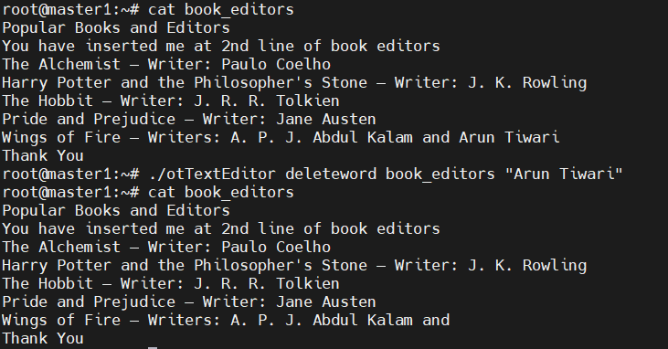

- Insert word
  - ./otTextEditor insertword book_editors "The Hobbit" "Boomerang"
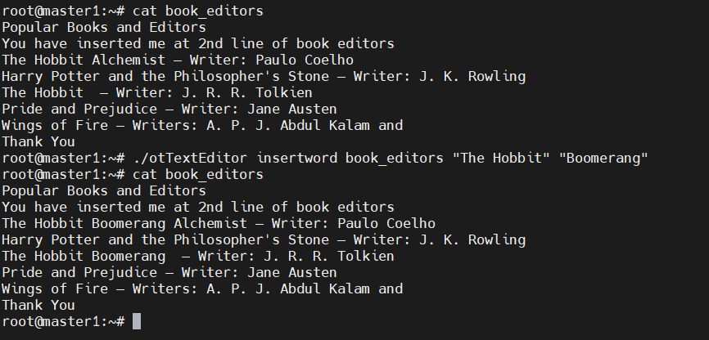

- Delete line number 3
  - ./otTextEditor deleteline book_editors 3

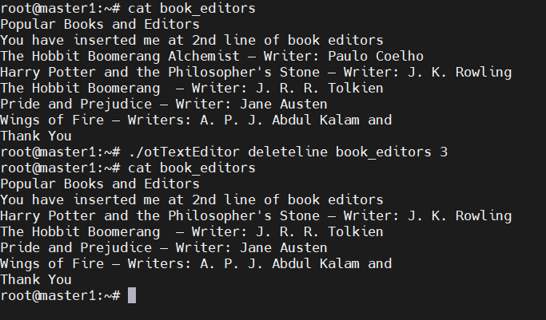

- Delete lines containing "Ubuntu"
  - ./otTextEditor deletelinecontaining book_editors Writer

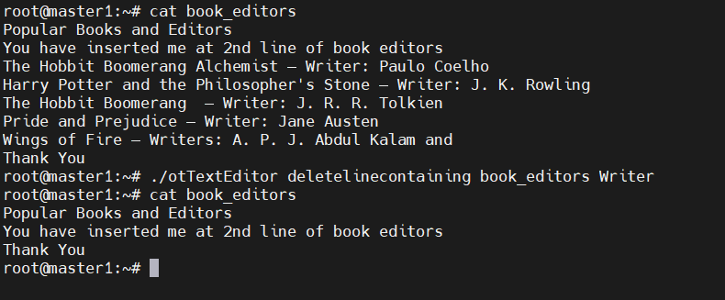
- Show file
  - ./otTextEditor show book_editors

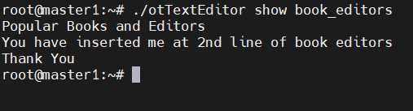

- Count lines
  - ./otTextEditor countlines book_editors

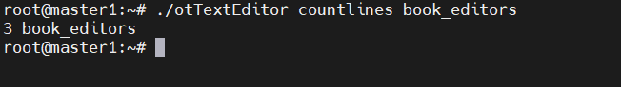

- Count words
  - ./otTextEditor countwords book_editors

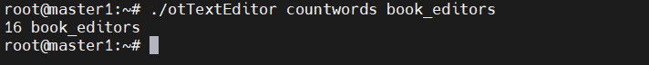

- Show line numbers
  - ./otTextEditor linenumbers book_editors

